Metaforum Documentation

Tody Prasetya – 2440027530

Xampp version that is used is v3.3.0 and Visual Studio Code version that is used v 1.62.3

*More Information :*

* A picture containing graphical user interface

  Description automatically generated*Login Page*

In this page, user can login if they already have an account or click “Sign Up Here!” to make an account.

* *Forgot Password*

When the user click “Forgot Password” the user will be redirected to a link where user can input an email addresss. The email address is used to change the password that the user has forgotten.

After the user has input their email address, an email will be sent. If the user click the button, the user will be redirected to a link below to change their password.

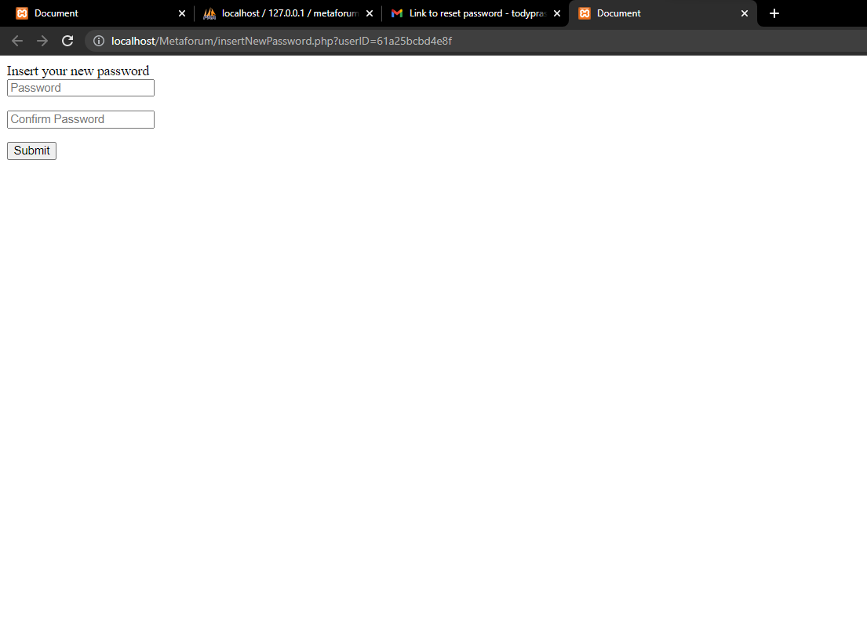After the user has inserted the new password, changes will be made in the database accordingly.

* *Sign Up*

User can sign up here, after they sign up, an email will be sent to their email address to verify their account

* Graphical user interface, text, application

  Description automatically generated*Home Page*

User can view a thread, by clicking the group and choosing the category which will display threads according to the category. User can “love” a thread which will dynamically change the amount of favorites on the post. Clicking the thread also add views to the thread which is display beside the eye logo. User can also reply which will show a form in the bottom of the page. User that has been moderated on this thread or category will not be able to see the reply button

* Graphical user interface, text, application

  Description automatically generated*Reply form*

If the user has inserted the reply and clicked the “Y” button, a reply will be made.

* Graphical user interface, text, application

  Description automatically generated*Create Thread*

User that is not pardoned can see and click the create thread button which will show a form in the bottom of the page to insert the thread title and description.

* Graphical user interface, text

  Description automatically generated*Report Thread*

If the user chooses to report a thread, a form will show up and the user can report a thread and input their explanation on why the thread was reported. Reported thread can be seen by the moderator that has been assigned to the category of the thread.

* Profile

If a user click the display picture of a user in the thread, they will be redirected to a page that shows the information of the user.

* Graphical user interface, text, application

  Description automatically generated*Account Management*

User can also change their account by clicking the “Account” button in the top of the page. Changing Password, and Deleting Account will require the user to access the link on the user email’s inbox. (Note that deleted account **will not be** deleted from the database, but deleted account will not be shown on threads, and can’t be used to log in again, *for backup purposes*). User can change their display name only ones every 30 days.

* *Moderator Homepage*

Moderator has a “User Management” button that will show the reported threads assigned to their category.

* *User Management*

In the user management page, moderator can see the thread title that has been reported, the username that has been reported, and who reported it.

* Graphical user interface, text, application

  Description automatically generated*Moderating*

By clicking the thread, it will show the thread content, and a button to moderate the user. Moderator can choose to Pardon, Silenced, or Banned the user and how long will the effect takes ranges from 3 hours, 6 hours, 12 hours, 24 hours.

*Additional Notes :*

* To assign moderators, the moderators must be injected through database. By making a user and setting the “Role” attribute in user table to “2” and insert the UserID and CategoryID in the moderator_category table.
* To help the grader on scoring the project, accounts has been made

|  |  |  |  |  |
| --- | --- | --- | --- | --- |
| Username | Email | Verified | Role | Password |
| siteadmin | supermetaforum@gmail.com | True | Site admin |  |
| Usernomor1 | usernomor1@gmail.com | True | User | binusmaya123 |
| Usernomor2 | usernomor2@gmail.com | False | User | binusmaya123 |
| Moderatorfps123 | moderatorfps@gmail.com | True | Moderator(fps) | binusmaya123 |

* Text, letter

  Description automatically generated
* There is an event in phpMyAdmin that triggers every minutes to lift moderation on user that already passed their banned period.